|  |
| --- |
|  |
| 新概念 3 册 |
| Lesson20 |

Lesson 20 Pioneer pilots

**pioneer [paɪə'nɪə(r)]**

**n. 先驱；v. 开拓，探索**

Young Pioneers

Henry Ford was a pioneer in the auto industry. The Wright brothers pioneered in early aviation. break new ground

Deng Xiaoping’s reform programs broke new ground in China. lead the way

The company led the way in developing environment-friendly products.

lord [lɔ:d]

**n. 对（英国）贵族的尊称，勋爵**

lord n. 对贵族 (noble / aristocrat) 的尊称

Lord Northcliffe Lord Byron

duke marquis earl

**viscount baron**

sir n. 对爵士 (knight) 的尊称

Sir John Hawkwood

overland ['əʊvəlænd]

**adj. 陆上的；adv. 通过陆路**

an overland journey

overland adv. 通过陆路 = by land

We travelled overland / by land to Hangzhou. by sea / by air

by bus / train / car / ship / boat / plane etc.

on foot

**drive (from …) to … fly (from …) to …**

**sail (from …) to …**

take a bus / taxi / train / ship / boat / plane etc.

*In 1908* Lord Northcliffe offered a prize of $1,000 to the first man who would fly across the English Channel.

offer sb. sth. offer sth. to sb.

In 1908 Lord Northcliffe offered a prize of £1,000 to *the first man who would fly across the English Channel*.

An aeroplane offers *you* an unusual and breathtaking view of the world.

Shops cater for the do-it-yourself craze not only by running special advisory services for novices, but by offering *consumers* bits and pieces which they can assemble at home.

offer to do = volunteer to do

In times of peace, when business was bad, Hawkwood and his men would march into a city-state and, after burning down a few farms, would offer to go away if protection money was paid to

them.

He offered to train Mendoza and his young pupil was quick to learn. a ￡1,000 of prize X

a prize of ￡1,000 √ a ransom of ￡1,000 a reward of ￡1,000 a debt of ￡1,000

a fund of ￡1,000

a scholarship of ￡1,000 an investment of ￡1,000

fly across the English channel

动词 + across + 宾语

**cross + 宾语 + 方式状语**

cross the English channel by plane the (English) Channel

strait

the Bering Strait the Taiwan Strait

Looking at his watch, he saw that it was one o'clock, but the bell struck thirteen times before it stopped.

I hadn’t waited long before he came. I shaved before I went to the party.

Alfred stayed in the camp a week before he returned to Athelney.

He had travelled only seven miles across the Channel when his engine failed and he was forced to land on the sea.

The plane had been planting seed for nearly a month when it began to rain.

Shrugging my shoulders, I began to walk away when, a moment later, he ran after me and thrust the pen into my hands.

make … attempt to do

make an / no / little / the first / another attempt to do

Latham made another attempt a week later and got within half a mile of Dover, but he was unlucky again.

造句：过了一个多月才有人发现了这具尸体。

Over a month passed before the body was found.

造句：过了十年 (decade) 多才有人出来揭示 (reveal) 了这个秘密。

Over a decade passed before the secret was revealed. in the early / late morning / afternoon / evening

at dawn / the crack of dawn / daybreak / sunrise at dusk / sunset / sundown / twilight

**take off 起飞 land 着陆**Flight No.714 took off / landed at 8:30 a.m. **take off sth. 脱衣服**

put on sth. 穿衣服

He took off / put on his coat.

take … off … 使……脱离……

It is almost impossible to take your mind off the journey. She was so pretty—I couldn't take my eyes off her.

“Have you seen James without his beard?” “I know—it takes years off him!”

take time off

Do you still live there?

Oh yes, yes. My husband‘s there now. He couldn't take time off to come to New York with me. I have to take time off from work / school to go to the dentist.

take a day off

take the afternoon off

He has to travel 20 miles to work every day.

fail v. (fml.) （零部件）失灵

The brakes failed and the car crashed into a tree.

**break down v.（交通工具, 大型机器） 抛锚, 停止工作**The car / bus / train / washing machine broke down. **malfunction v. (fml.) 出故障**

The satellite entered the orbit and quickly malfunctioned.

sth. goes wrong with … 出故障

Something’s gone wrong with my computer.

fail to do 没能完成某事

When the journalist again failed to reply, the editor reluctantly published the article as it had originally been written.

be forced to do

She was forced to retire early due to ill health.

… and he had to make a forced landing.

be / feel obliged to do

However, as the evidence began to accumulate, experts from the Zoo felt obliged to investigate, for the descriptions given by people who claimed to have seen the puma were extraordinarily similar.

be / feel compelled to do

President Nixon felt compelled to resign.

be / feel impelled to do

I felt impelled to tell her the truth.

be / feel bound to do

All the countries are bound to submit to the regulations.

☓ be / feel necessary to do ☓

√ It is necessary for … to do √

**must do / have to do** float on the water ride the waves

pick up ↔ sb.

I'd really like to pick up Grandpa at the railroad station.

Railroad stations or airports, Grandpa always tells us he'll get here by himself. He's something!

save / rescue

When you rescued your trousers, did you find the note was whiter than white?

When a passing tanker rescued them five days later, both men were genuinely sorry that they had to leave.

salvage

He tried desperately to salvage belongings from the burning house. The salvage operation had been a complete failure.

pick up ↔ sth.

The phone rang and I picked it up.

He has often described to me how he picked up a masterpiece for a mere ₤50. pick up where we left off

After lunch shall we pick up where we left off?

Chandler: Wait! I just want you to know that ... I'm so happy you're going to be here. Janice: Oh, me too ...

Chandler: Because ... that way ... we can pick up where we left off. Janice: Huh?

Chandler: I never stopped loving you.

Louis Illinois Calais Charles Chamonix

Louis Blériot (1872-1936), French engineer and pioneer aviator.

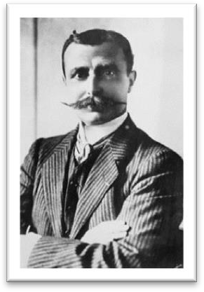

After designing and building various types of experimental aircraft, he concentrated on

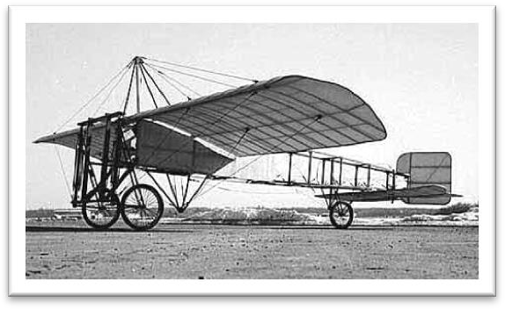developing the monoplane.

On July 25, 1909, he flew from Calais, France, to Dover, England, in one of his monoplanes, becoming the first aviator to cross the English Channel in a heavier-than-air machine.

During World War I Blériot's factory produced about 10,000 airplanes for the armed forces of France and the other Allied powers.

**model** n.（车辆、机器的）型号the latest model

the most popular model My car is the latest model.

They produce a range of different computers, but this is the most popular model.

flight aviation

**voyage navigation**

造句：早在 20 世纪 30 年代，红军就完成了伟大的长征，在这期间他们走过了 25,000 里。As long ago as the 1930’s, the Red Army had completed the successful Long March during which they covered 25,000 li.

stick it out 坚持下去

Latham, however, stuck it out.

Rachel: Oh God, I hate my job, I hate it, I hate my job, I hate it. Monica: I know honey, I'm sorry.

Rachel: Oh, I wanna quit, but then I think I should stick it out.

**It seems / looks *as if / as though* … 看似, 好像……**

造句：看似他们之间将有一次激烈的争吵 (a heated argument)。

It seemed / looked *as if / as though* there would be a heated argument between them. a car / boat / horse / swimming race

match / game

a boxing / basketball / football / volleyball match / game

Boxing matches were very popular in England two hundred years ago. contest

a speech / beauty / dance contest

promise to do

It promised to be an exciting race across the Channel. It promises to be warm today.

Groundbreaking research by two French geophysicists promises to shed some light on the mystery.

set out / off start out / off

Four days after setting out, while the Titanic was sailing across the icy waters of the North Atlantic, a huge iceberg was suddenly spotted by a lookout.

The next man to approach me was selling expensive pens and watches.

within … of … 离……不到……

I live within a mile of the city center.

The company is within a week of bankruptcy.

for the second time at the second time for the first time

**at the first time**

In 1929, three years after his flight over the North Pole, the American explorer, R.E. Byrd, successfully flew over the South Pole for the first time.

Is something still wrong, Robbie? I'll be OK.

Going away to college for the first time always makes one a little nervous. I guess so. I'll be OK. I just need time to think.